**[http://digitalhealthaccelerator.com/nydwp14/site/wp-content/uploads/New-York-Presbyterian-Logo.png](http://www.nyp.org/)**



**Weill Cornell Medicine & NewYork-Presbyterian**

**DEPARTMENT OF SURGERY**

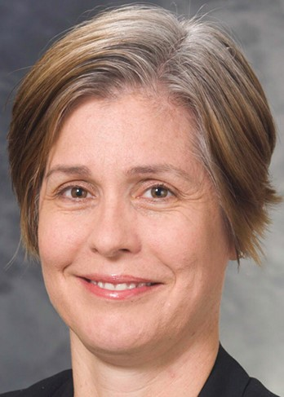

**3rd Annual Diversity Lectureship**

**“Sticky Floors & Glass Ceilings”**

**Caprice C. Greenberg, MD, MPH**

**Professor and Vice Chair of Research,**

**Morgridge Distinguished Chair**

**in Health Services Research and**

**Director, Wisconsin Surgical Outcomes**

**Research Program, Department of Surgery**

**University of Wisconsin School of Medicine**

**and Public Health**

**Madison, Wisconsin**

**Monday, March 5, 2018**

**8:00 a.m. in Uris Auditorium**